* * LEGAL DISCLAIMER *

DISCLAIMER: Forex trading involves substantial risk of loss and is not suitable for every investor. The valuation of forex pairs my fluctuate and may lose more than the original investment. The impact of seasonal and geopolitical events factor into market prices. The highly leveraged nature of Forex trading means that small market movements will have a great impact on your trading account, and this can work against you, leading to large losses and you may sustain a total loss greater than the amount you deposited into your account. You are responsible for all the risks and financial resources you use and for the chosen trading system. You should not engage in trading unless you fully understand the nature of the transactions you are entering into and the extent of your exposure to loss. If you do not fully understand these risks you must seek independent advice from your financial advisor. All trading strategies are used at your own risk. Any content in this Expert Advisor (EA) should not be relied upon as advice or construed as providing recommendations of any kind. It is your responsibility to confirm and decide which trades to make. Trade only with risk capital; that is, trade with money that, if lost, will not adversely impact your lifestyle and your ability to meet your financial obligations. Past results are no indication of future performance. In no event should the content of this correspondence be construed as an express or implied promise or guarantee. Loss-limiting strategies such as stop loss orders may not be effective because market conditions or technological issues may make it impossible to execute such orders. Any strategies provided in this correspondence EA is intended solely for informational purposes and is obtained from sources believed to be reliable. Information is in no way guaranteed. No guarantee of any kind is implied or possible where projections of future conditions are attempted. None of the content presented in this EA constitutes a recommendation that any particular security, portfolio of securities, transaction or investment strategy is suitable for any specific person.

Thank you for your help in testing my EA. This EA is still in development and should NOT be trading in a funded account. Please run it in a simulated account ONLY!

There are a few requirements that you need to understand and follow while testing this EA.

1. The EA trades need to be the only trades taking in the account. Please do not take any additional trades yourself.
2. The Chart needs to be the EUR/USD set on 5 minute time frame.
3. Alveo needs to be running with the chart and time frame selected as much as possible.
4. If Alveo closes or if the chart or time frame change the EA should stop running. Please verify this if you change accounts.
5. At the end of the day on Friday, please download the close trade log as a csv file and email to me at [gpdno@mac.com](mailto:gpdno@mac.com)

The strategy is a trend reversing strategy based on the CCI. There are actually two separate, but similar, strategies running simultaneously. One has an aggressive entry, the other has a conservative entry. They are both based off Kent’s Hamilton Strategy the he should the group a few weeks back. All the parameters are pre-defined and not user adjustable.

The strategy will ignore the Sunday open and start trading at 12:00 midnight GMT. The strategy will also not trade 30 minutes before or after Alevo’s daily maintenance. Other than those times, if the EA is running, it will be looking for set ups.

Please contact me at [gpdno@mac.com](mailto:gpdno@mac.com) if you have any questions. Thank you.

Peace,

Greg

How to install an EA in Alveo

1. Click on the </> icon. Select Expert Advisor from the Dropdown menu and the Select New

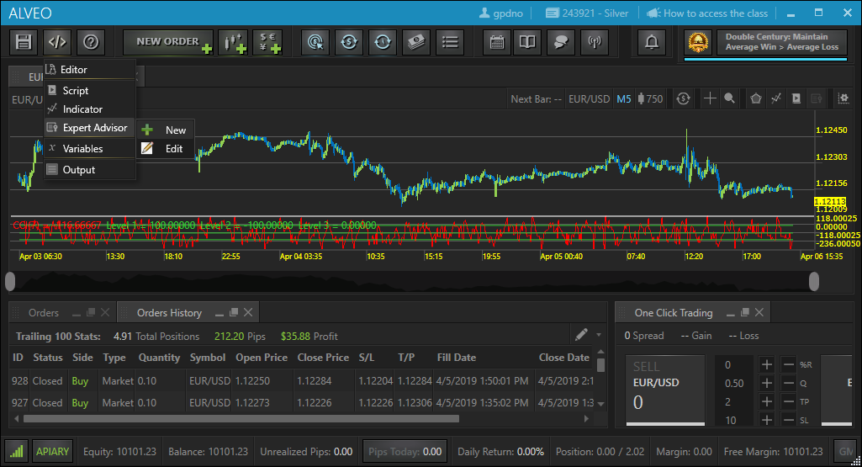

1. The Code Wizard dialog box will pop up. Select Next

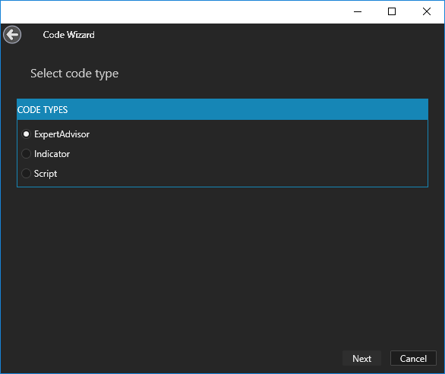

1. In the Name field – Type GKAH_EA

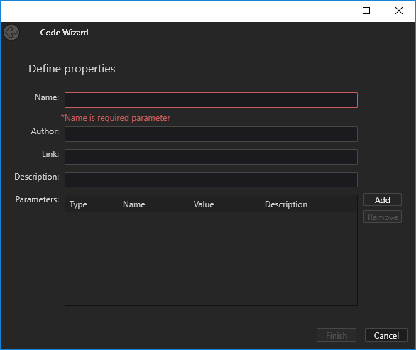

1. The other fields are not needed. Press Finish.

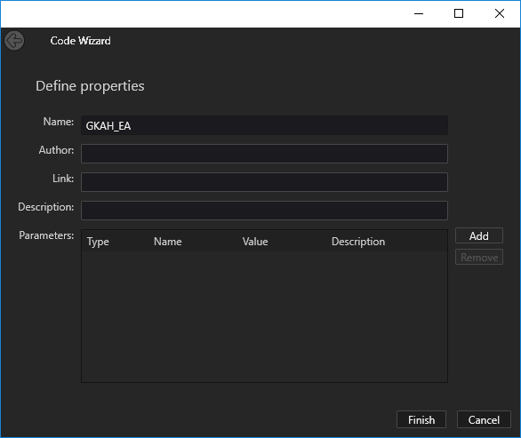

1. This will open up Alveo’s code editor. It come populated with a default template. We need to delete this template.

Double click anywhere inside the editor to select a piece of code and hit “Ctrl A” on your keyboard to select all.

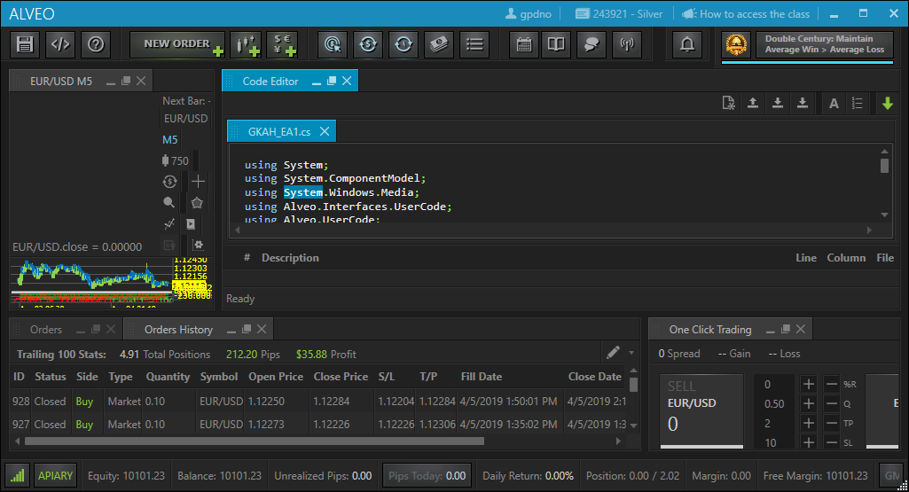

1. Hit the Delete or backspace key to delete the code.

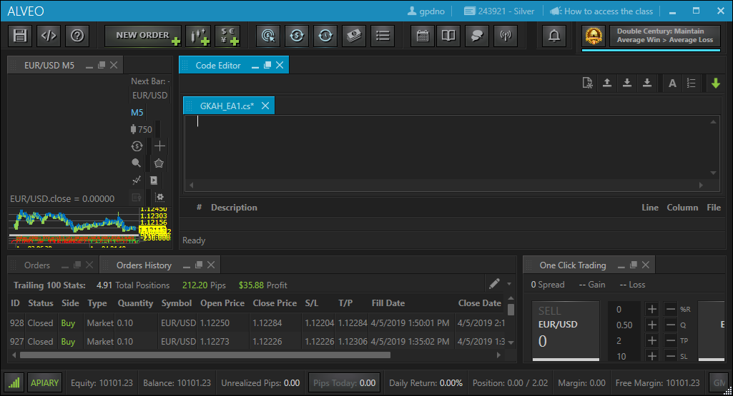

1. Open the Notepad pad app.

From File, Open, and in the dropdown select All Files (*.*)

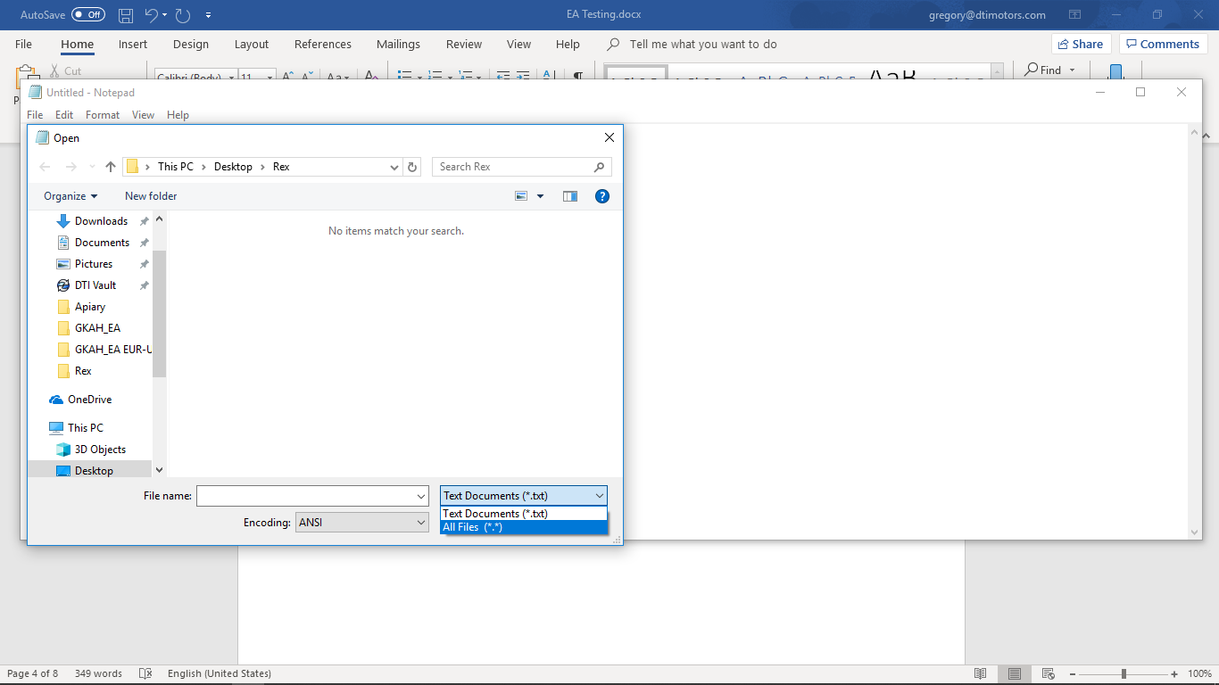

1. Open the GKAH_EA file I provided.

Select All and Copy.

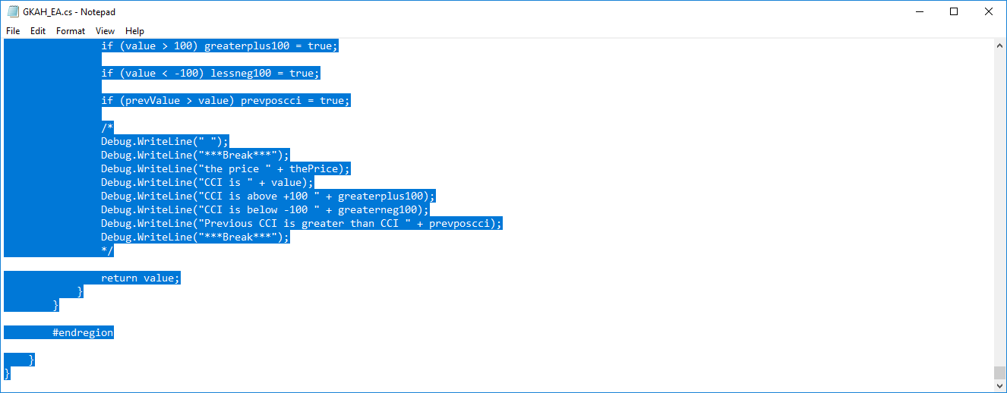

1. Return to Alveo and paste the code into the code editor.

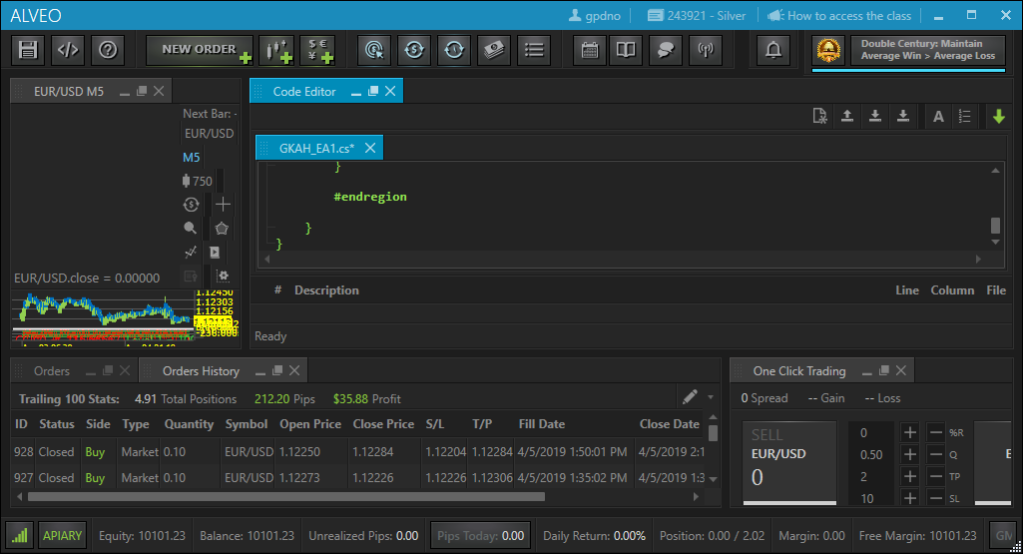

1. Click on the Save icon to save the code.

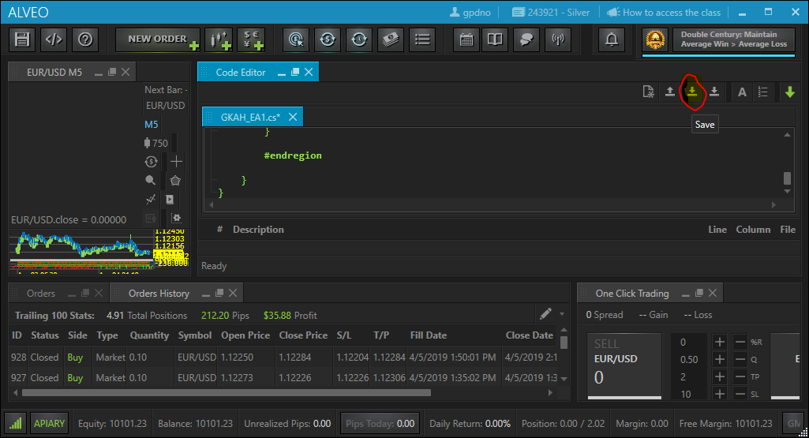

1. Click on the Build Button.

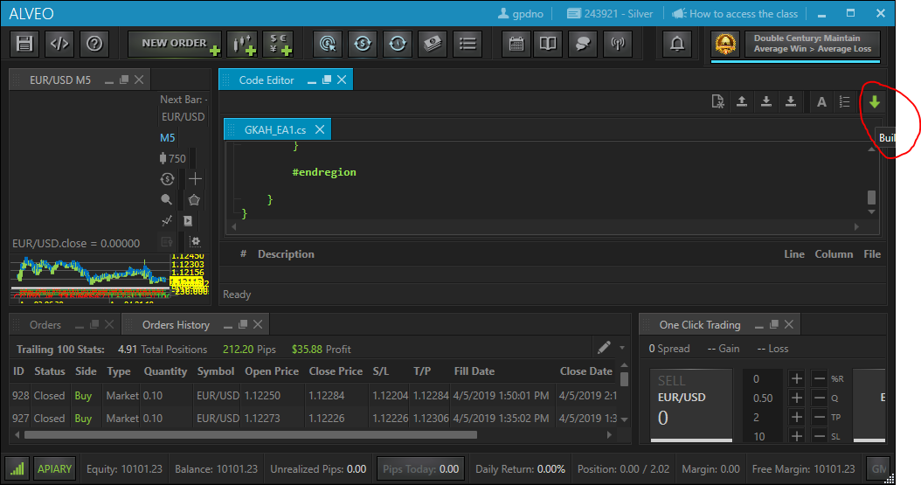

1. After a few minutes you should see Build Successful.

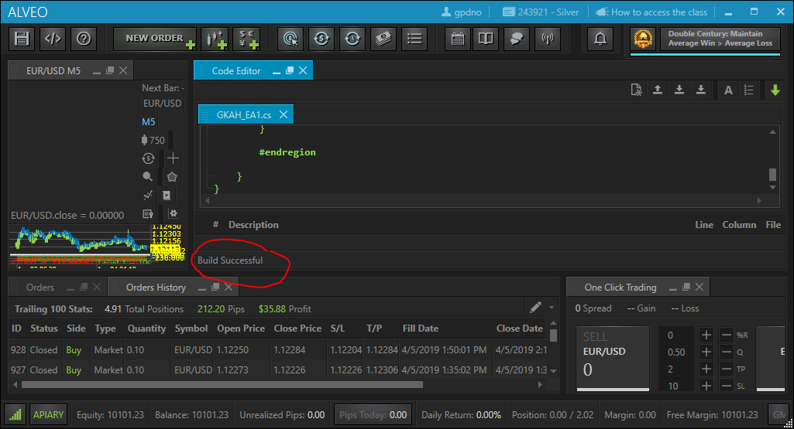

1. The EA is now ready to start trading.

Verify you are in the correct account.

Select the EUR/USD on a 5-minute chart.

Click on the EA button and select GKAH_EA from the drop-down menu.

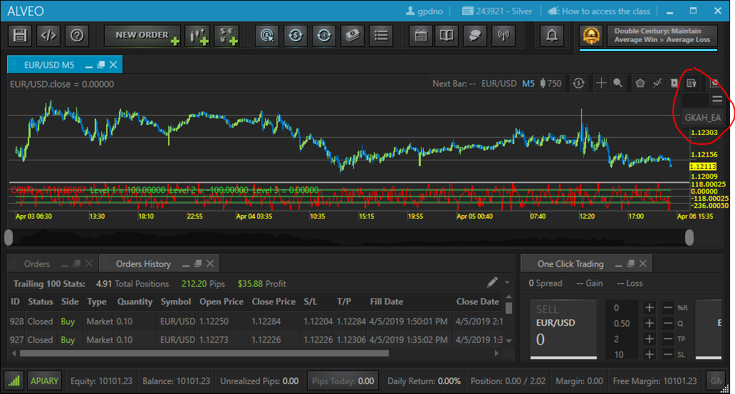

1. Click Ok in the dialog box. The EA will now initialize and begin to look for trades.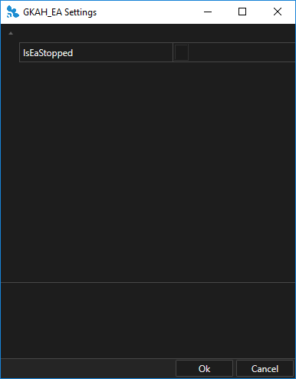
2. To verify, click on the log button in Alveo and you should see a bunch of stuff taking about GKAH_EA.

